**Objective Answers:**

1. **What is the total number of attributes in the customer table?**

The customers table has 3 attributes: CustomerID, CustomerAge, CustomerGender.

1. **How will you get the “Customer’s” ages in the “Order” tables according to customer IDs?**

In the Data view, select the Orders table.

* Click on Modeling in the top menu and then select New column.
* CustomerAge = RELATED(Customers[Customer Age])

1. **In analyzing the dataset with Power BI, ensure data cleaning to address inconsistencies and missing values before further analysis.**

In Power BI, we use Power Query Editor to:

* Removing duplicates.
* Handling blank rows by removing it.
* Ensuring data types are correct.
* Removing extra blank columns.

1. **How can we calculate the total revenue generated by all the sales?**

**Reference:**

The total revenue generated by all sales is as follows:

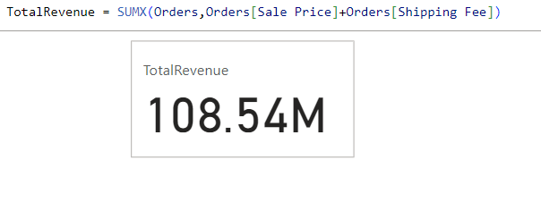

1. **What is the total number of unique customers who made purchases each year? Is there any increase in the number over the years?**

**References:**

The total no. of unique customers who made purchases each year as follows:

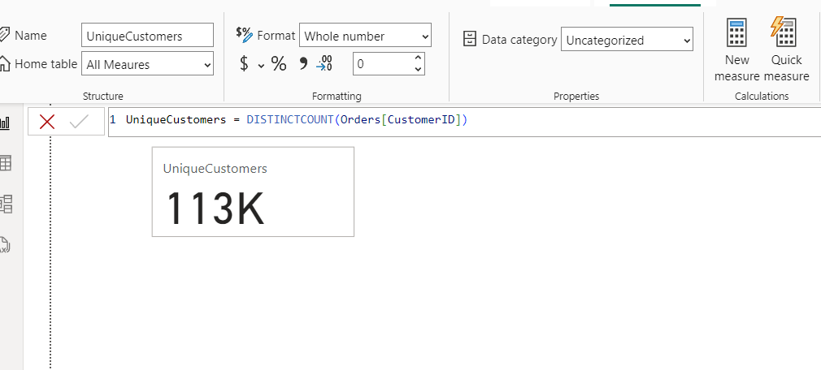

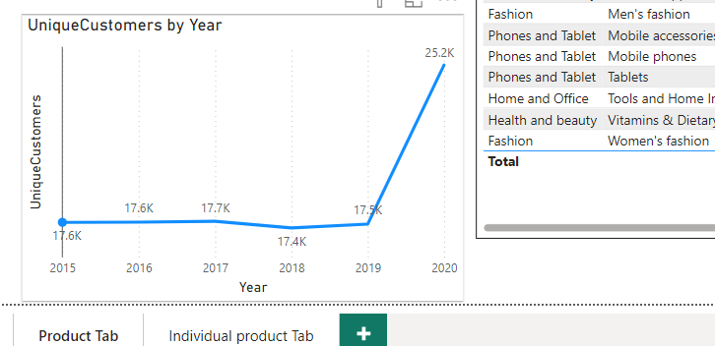

**Insights:**

* The unique customer count shows a steady increase from 2019 to 2020, indicating that successful marketing strategies or an expanding product range may have attracted new customers.
* The slight drop in unique customers from 2017 to 2018 could suggest potential issues such as product availability, pricing changes, or increased competition that may have impacted customer retention or acquisition.

1. **How can we determine the total number of unique products available in the company?**

**Reference:**

The total no. of unique products as follows:

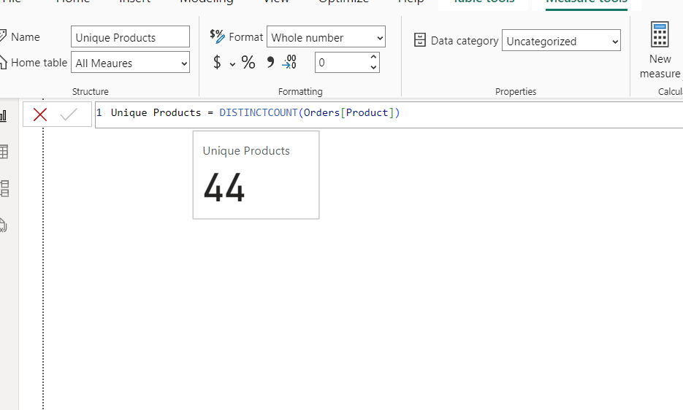

1. **What is the average number of days it takes for products to be delivered, get the metric for only the delivered orders.**

**Reference:**

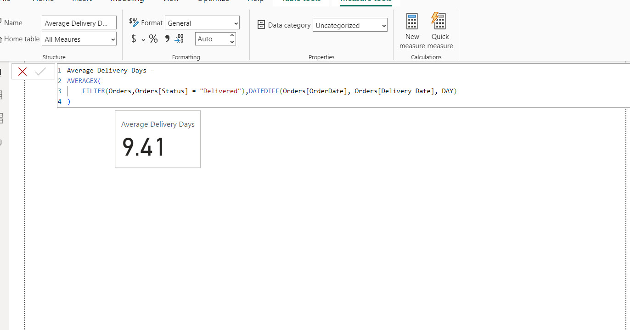

1. **Which products, categories, and subcategories are the most popular?**

**Reference:**

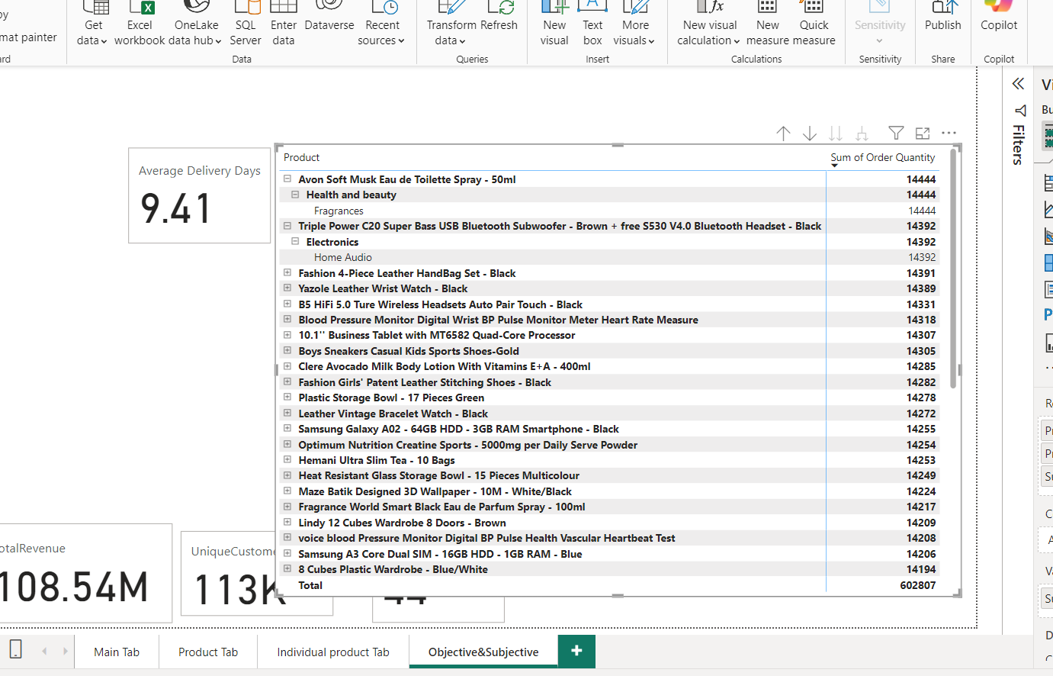

1. **Which products have seen an increase or decrease in sales over the year?**

**Reference:**

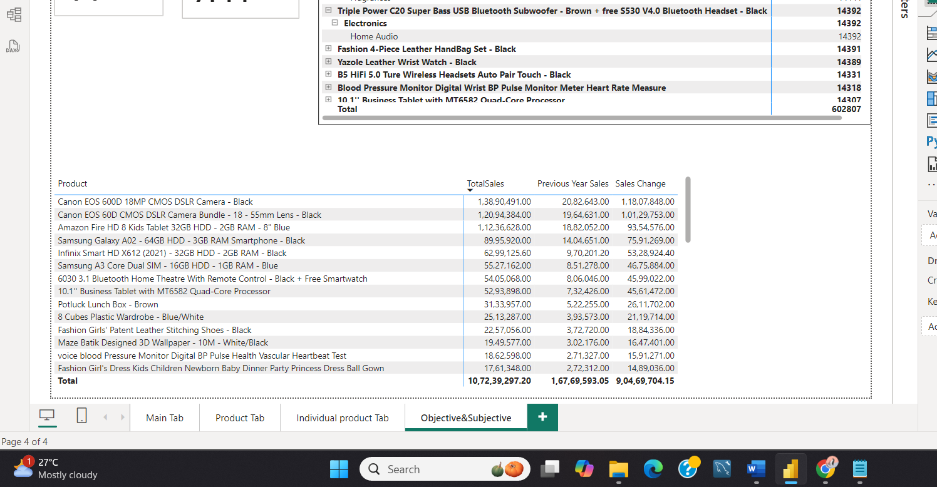

1. **While modeling the data relationships, what will be the type of relationship between the customer ID of Orders and customer tables?**

**Reference:**

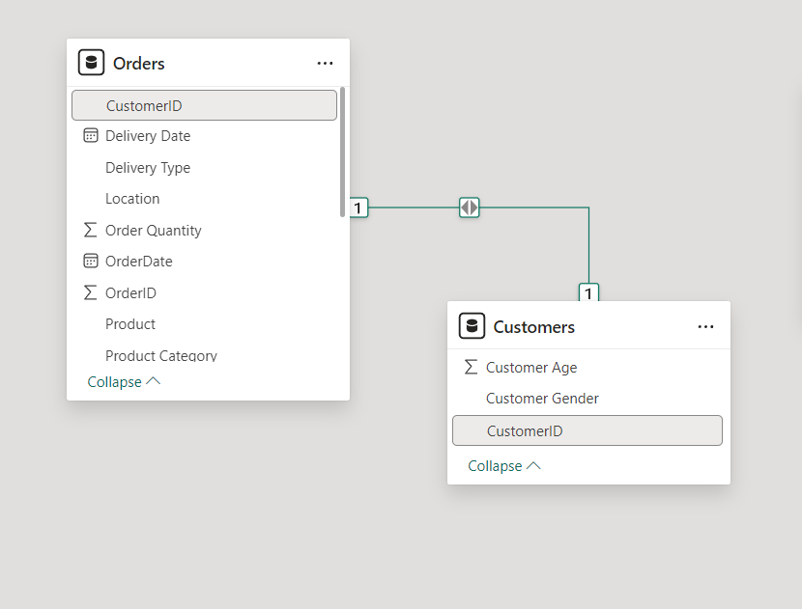

* While modelling the data relationships, the type of relationship between the customer ID of Orders and Customer tables is **one to one relationship**.

1. **How have you handled the null values in the data?**

* In Power Query Editor, filter out or remove null values to clean the data.
* In Power Query Editor, if there are any blank rows, remove them by eliminating rows from the top or bottom as needed.
* If there are blank values in the data, create a measure like this:
* Sale Price Cleaned = IF(ISBLANK(orders[Sale Price]), 0, orders[Sale Price])

1. **Were there any data format issues in the data, and if there were/are how you would handle them?**

* In our data, there was no need to change the data types.
* In our data, there was no need to modify the data types.
* If any issues had arisen with data types, I would have checked and transformed them in the Power Query Editor.
* The Power Query Editor is used to adjust data types when necessary, such as ensuring dates are recognized as date types, numerical values as numbers, and text as strings.

1. **When we add a column in Power Query what’s the code that comes in M language in the formula bar? What do you know about M-query?**

When we add a column in Power Query, the code that comes in M language in the formula bar is as follows:

**Syntax:**

= Table.AddColumn(PreviousStep, "NewColumn", each [Column1] + [Column2])

**Example:**

= Table.AddColumn(#"Removed Blank Rows", "Custom", each null)

**Reference:**

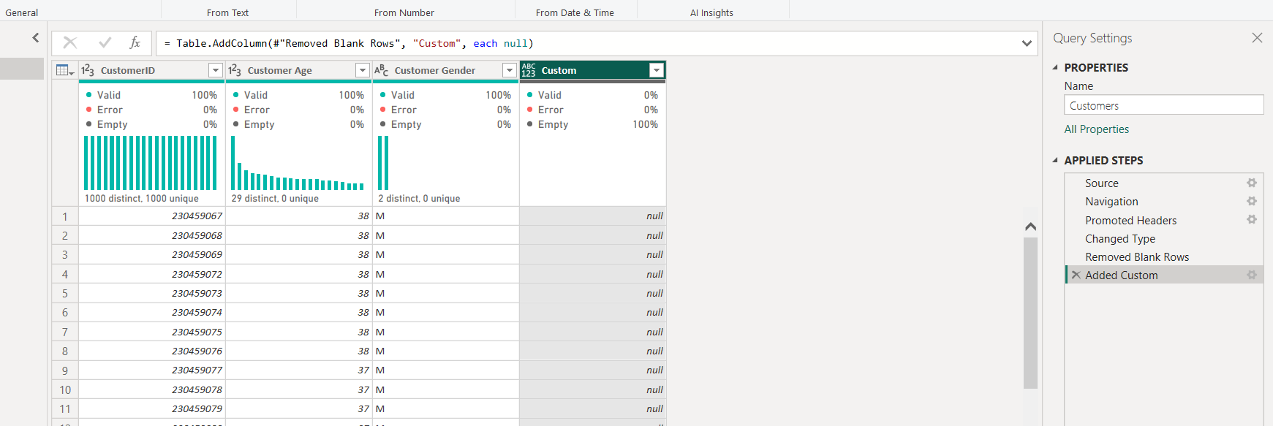

**About M-Query**: M is a functional language used in Power Query for data transformation and cleaning tasks. It allows for the creation of custom queries to manipulate data before loading it into the Power BI model.

1. **Identify the top 5 most valuable customers using a composite score that combines three key metrics: (SQL)**
2. **Total Revenue (50% weight): The total amount of money spent by the customer.**
3. **Order Frequency (30% weight): The number of orders placed by the customer, indicating their loyalty and engagement.**
4. **Average Order Value (20% weight): The average value of each order placed by the customer, reflecting the typical transaction size.**

**Reference:**

The top 5 valuable customers as follows:

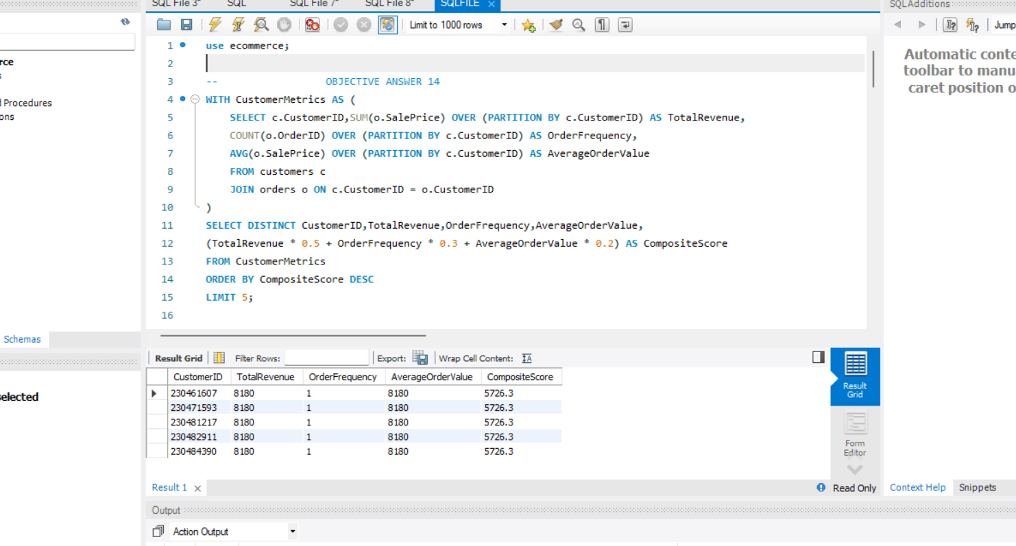

1. **Calculate the month-over-month growth rate in total revenue across the entire dataset. (SQL)**

**Reference:**

The month-over-month growth rate in total revenue as follows:

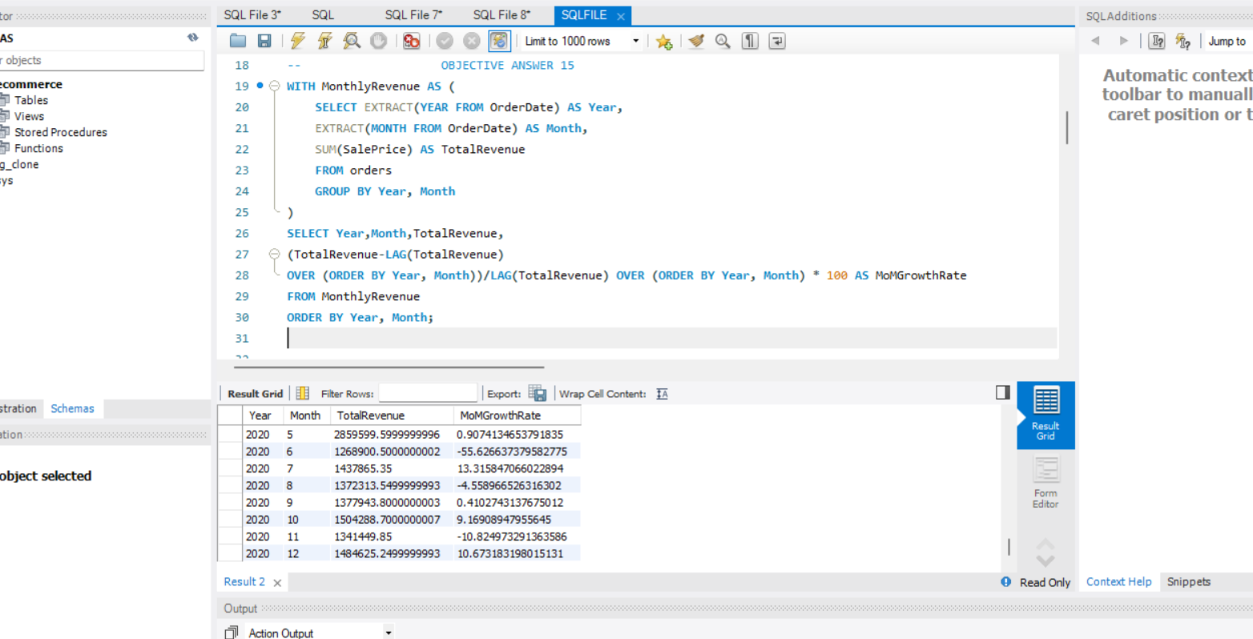

1. **Calculate the rolling 3-month average revenue for each product category. (SQL)**

**Reference:**

The rolling 3-month average revenue for each product category as follows:

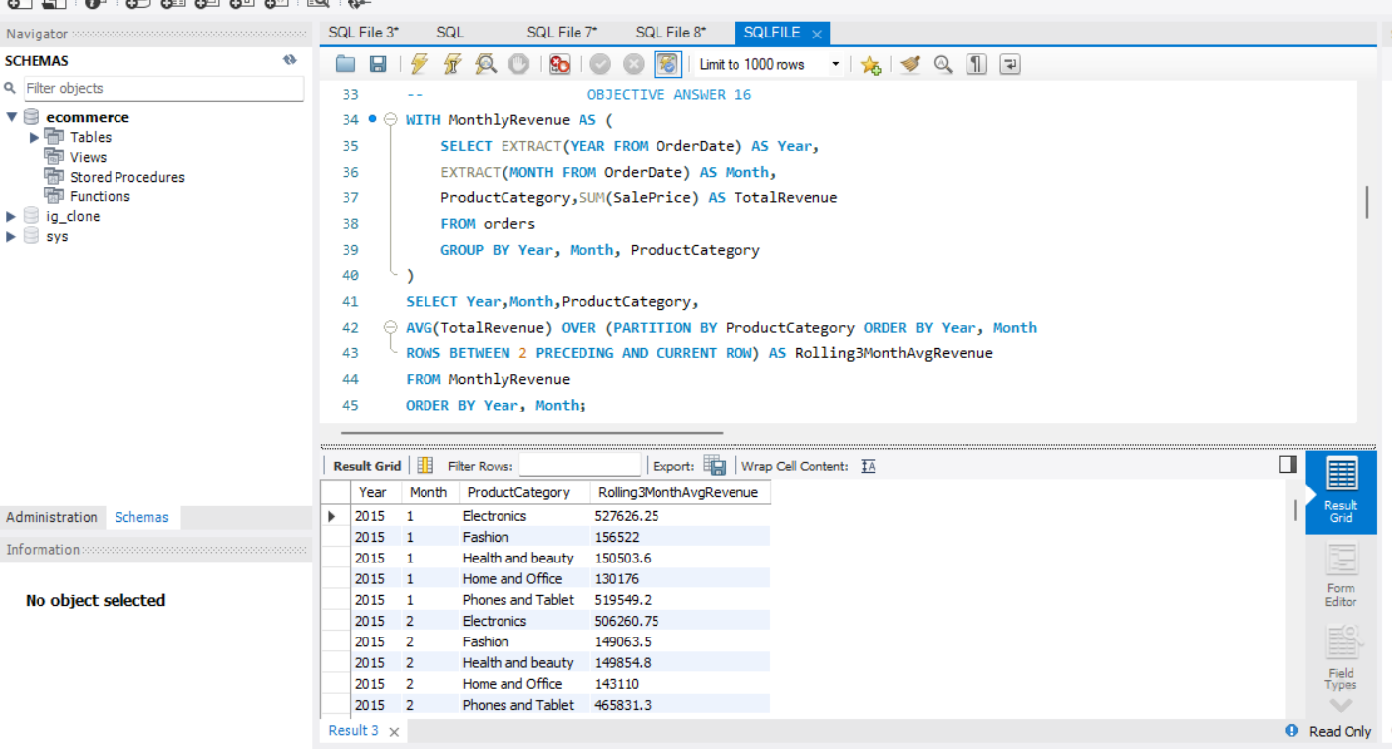

1. **Update the orders table to apply a 15% discount on the `Sale Price` for orders placed by customers who have made at least 10 orders. (SQL)**

**Reference:**

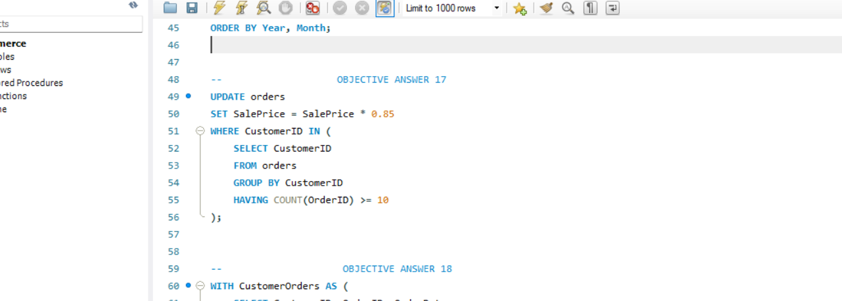

1. **Calculate the average number of days between consecutive orders for customers who have placed at least five orders. (SQL)**

**Reference:**

The average no. of days between consecutive orders as follows:

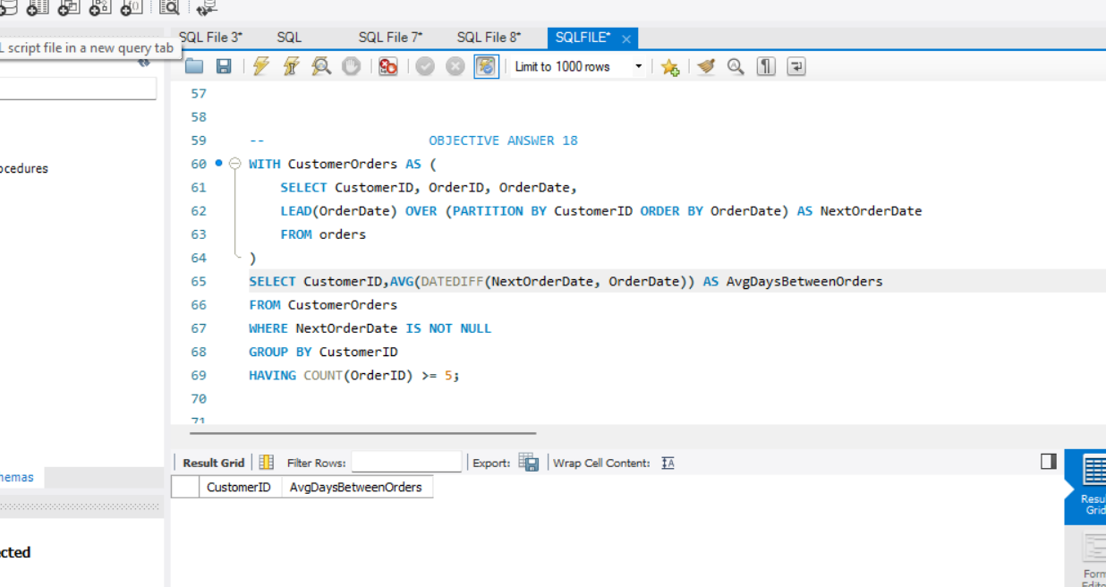

1. **Identify customers who have generated revenue that is more than 30% higher than the average revenue per customer. (SQL)**

**Reference:**

The revenue which is more than 30% higher than average revenue as follows:

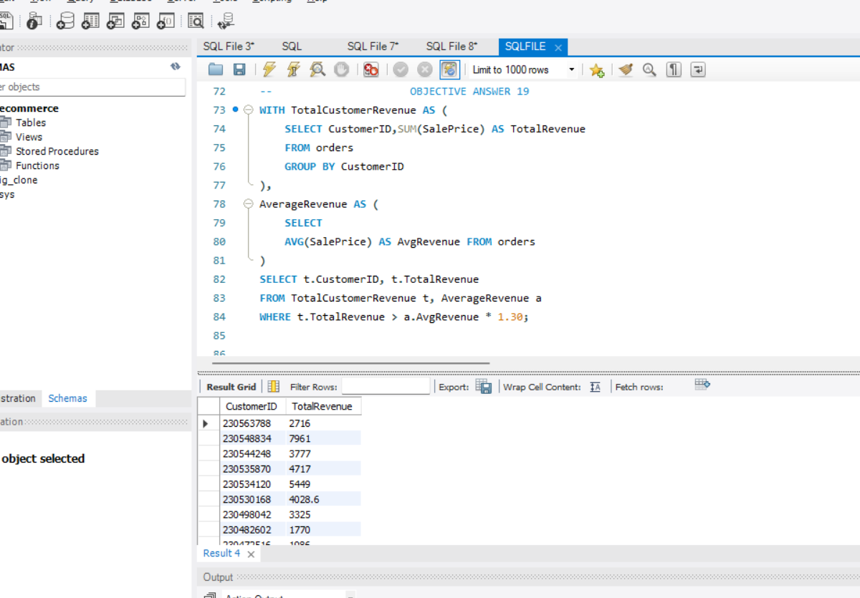

1. **Determine the top 3 product categories that have shown the highest increase in sales over the past year compared to the previous year. (SQL)**

**Reference:**

The top 3 product categories which have highest increase in sales over past year as follows:

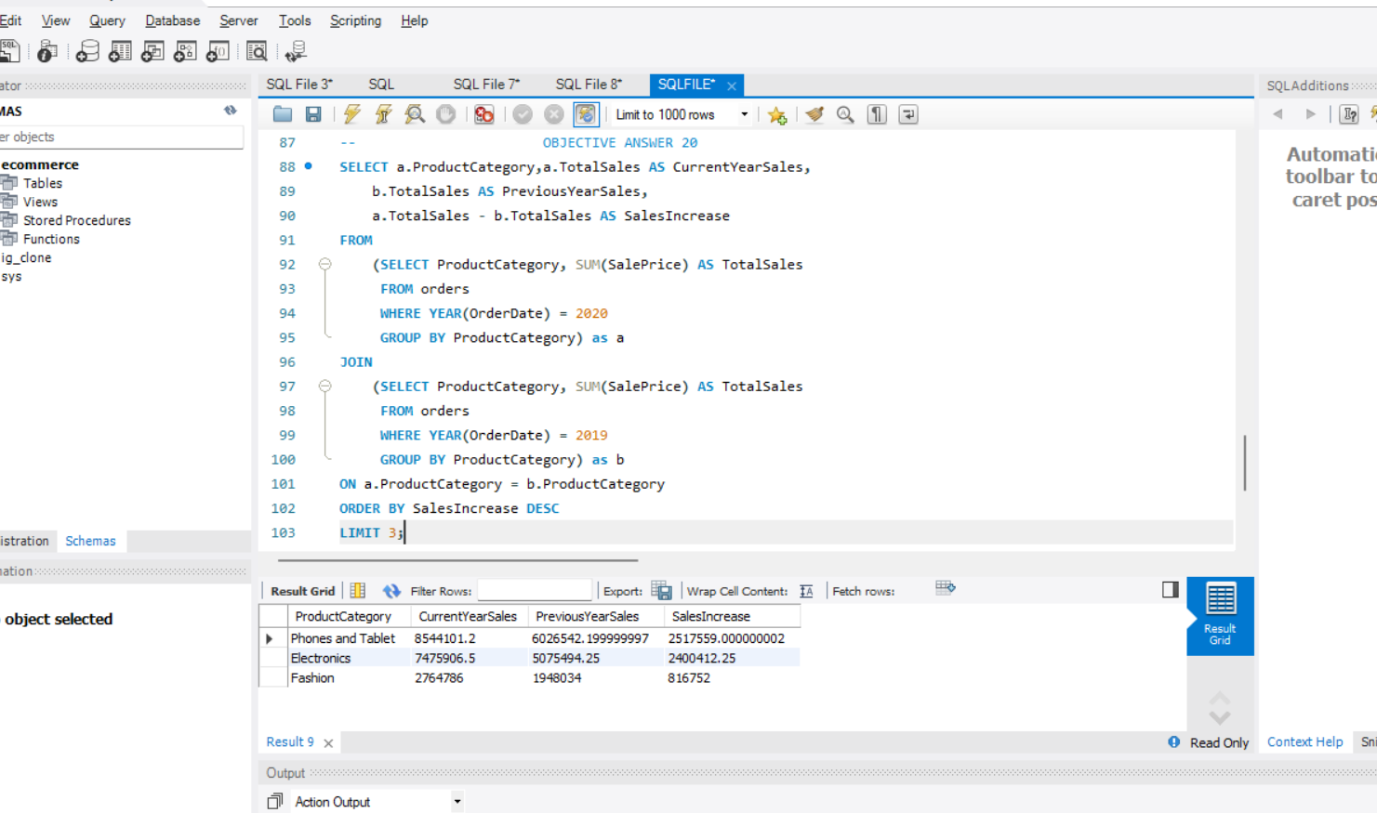

**Subjective Answers:**

1. **Explain the revenue breakdown by year and by-product. Evaluate how different products contribute to annual revenue and come up with suggestions to increase the sales of the low-selling items.**

**References:**

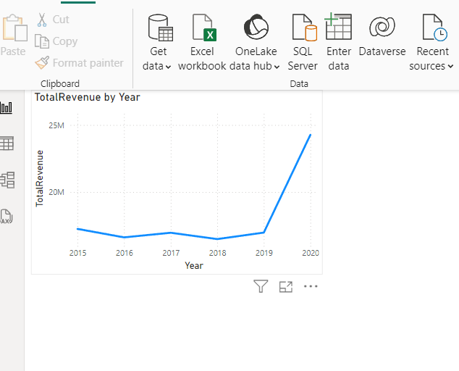

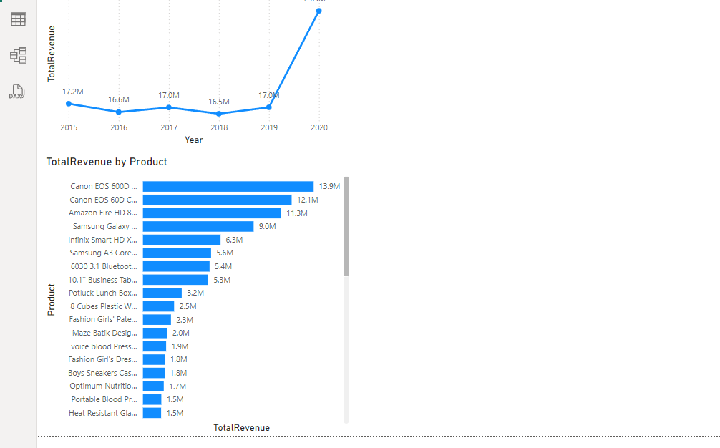

**Suggestions**:

* Increase marketing efforts for low-selling items, as shown in the graph, which are at the bottom of the sales performance.
* Bundle low-performing products with popular ones. This strategy encourages customers to purchase the less popular item along with the high-performing product, potentially boosting its sales.
* Use customer feedback to enhance product features or descriptions, ensuring they better meet customer needs and drive higher sales.

1. **How many products were returned? Use a DAX function to get this metric. Examine the possible reasons for returns and consider how this metric could indicate improvements in product descriptions or quality control.**

**Reference:**

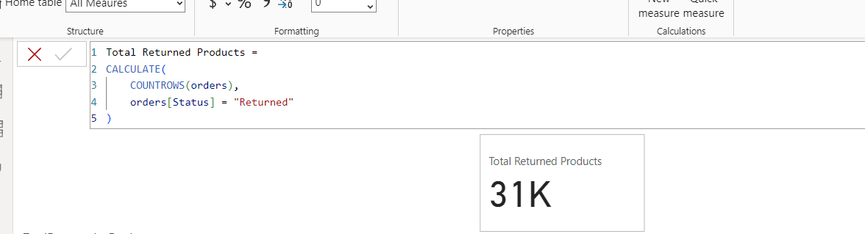

There were 31k products returned as shown above.

**Reasons for Returns:**

* **Product not as described**: This indicates a need for better product descriptions or more accurate images to align with customer expectations.
* **Defective items**: This suggests a need for improvements in quality control to ensure products meet the expected standards before reaching customers.

**Suggested Improvements:**

1. **Enhance Product Descriptions:**
   * Ensure that all relevant details, such as size, materials, and features, are clearly listed.
   * Use multiple images from different angles to give a comprehensive view of the product.
   * Include user-generated content, such as photos and testimonials, to provide a more realistic and trustworthy representation of the product.
2. **Quality Control Measures:**
   * Implement stricter quality control checks before products are shipped to ensure consistency and reduce defects.
   * Create a system for collecting and analyzing customer feedback on product quality to continuously refine and improve the quality control process.
3. **Whenever a customer goes to Amazon, they’ll filter the most rated products to buy the better category. Can you verify this using any visualization or table that the ratings of products impact their sales value?**

**Visualization:**

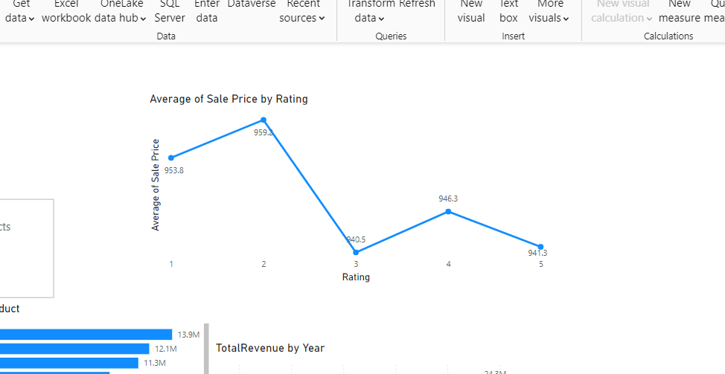

**Insights:**

* Customers are likely to prioritize highly rated products, as seen by the significant sales increase for products rated above 4. This highlights that ratings play a key role in purchasing decisions.
* Focusing marketing efforts on products with higher ratings can further enhance sales.
* Products with lower ratings should be analyzed for potential improvements. Customer reviews can offer valuable insights into issues that need addressing, which can help boost both ratings and sales.

1. **Investigate how revenue distribution varies across different locations. Explore which geographical areas contribute most to sales and consider the strategic implications for regional marketing and distribution efforts. How might location-based trends inform the company's market segmentation and resource allocation approach?**

**Visual Representation**:

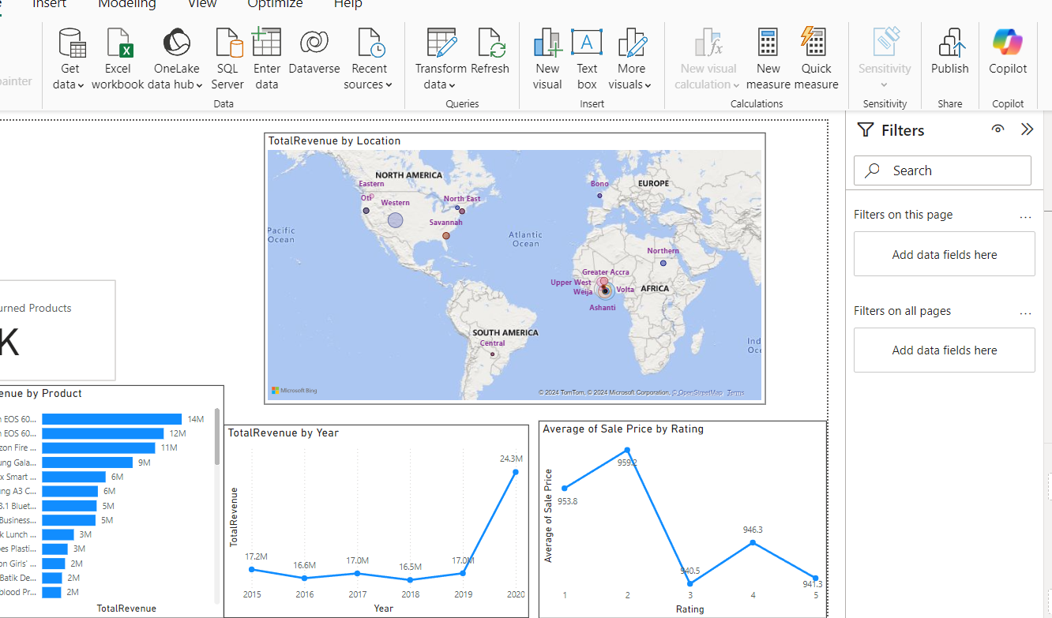

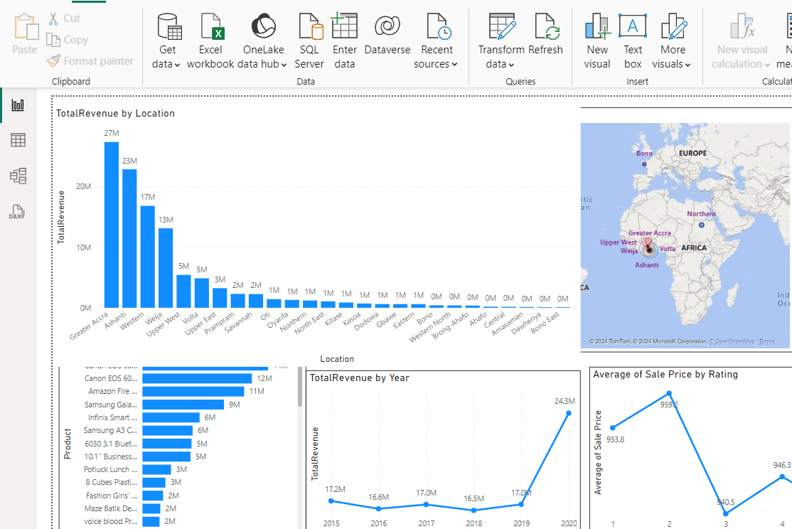

**Insights:**

* **Greater Accra** stands out as the highest revenue-generating region with 27M, indicating it is a crucial market for the business.
* Other regions, such as **Upper West** and **Eastern**, also contribute significantly to revenue, suggesting there are multiple strong markets.
* **Oti**, with relatively low revenues, highlights areas for potential improvement or targeted marketing efforts.
* **Location-based trends can provide valuable insights into a company's market segmentation and resource allocation strategy in several ways:**
  + By analyzing revenue data by location, the company can identify which regions contribute the most to overall sales, helping to focus efforts on high-performing areas.
  + Differences in purchasing behavior across regions may lead to the development of localized products or services that better meet the specific needs and expectations of customers.
  + Understanding the geographical distribution of revenue can aid in planning logistics and distribution strategies, ensuring high-demand areas are well-stocked while optimizing inventory in less productive regions.

1. **Determine which month could benefit from enhanced promotional offers to boost sales. Can you suggest some targeted marketing strategies here?**

**Reference:**

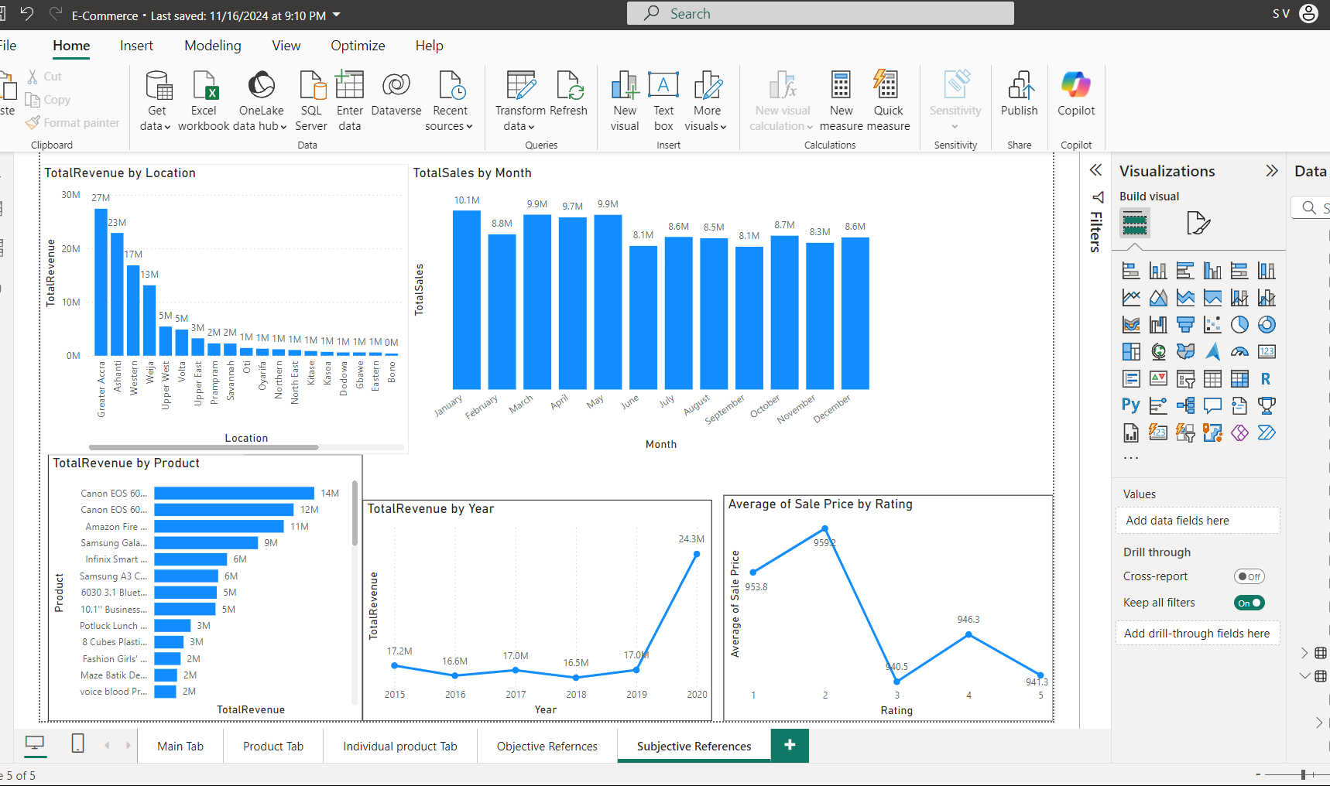

**Insights:**

* January (10.1M) sees the highest sales and doesn't need additional marketing efforts.
* June (8.1M), September (8.1M), and November (8.3M) experience a sales dip below the average (9M), and should be targeted with enhanced promotions.
* July, August, October, and December show consistent but lower-than-ideal sales, which can benefit from specific seasonal promotions.

**Targeted Marketing Strategies:**

* For June and September: Focus on summer sales and back-to-school promotions to attract customers during these slower months.
* For October: Build holiday momentum by offering early bird discounts, Halloween promotions, and sneak peeks of upcoming sales events.
* For November and December: Emphasize Black Friday deals, last-minute gift offers, "12 Days of Christmas" promotions, gift bundles, and loyalty rewards to maximize end-of-year sales.

1. **Identify which products may require increased marketing efforts. Which items have high prices yet underperform in sales?**

**References:**

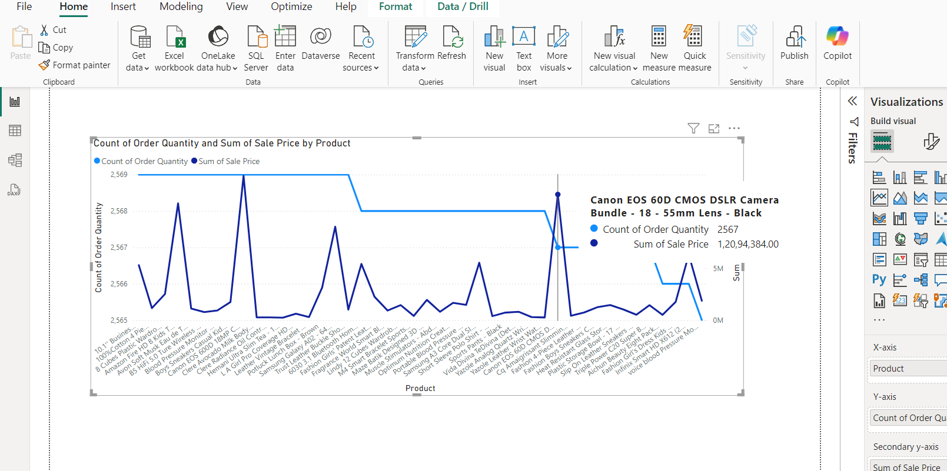

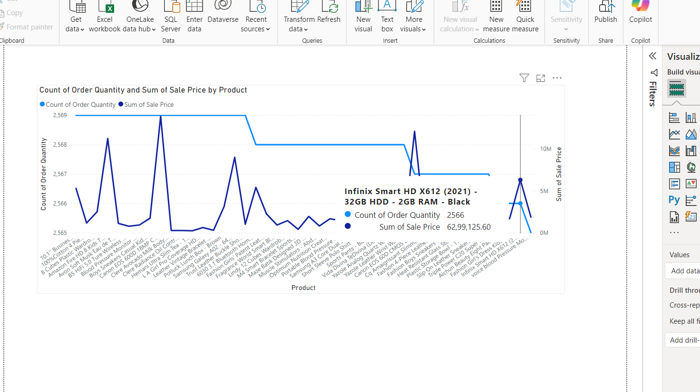

* After analyzing the product performance data, two items stand out due to their high prices but underperforming sales, as shown in the references above.
* These products are priced higher than most competitors in their category but have not achieved strong sales. It’s possible that customers perceive them as overpriced or are unaware of their value proposition.
* This combination suggests that these products may benefit from targeted marketing strategies to drive demand and better justify their pricing.

**Strategies for Increasing Marketing:**

* For expensive products, emphasize their **quality**, **features**, and any **exclusive offers** to highlight their value.
* Consider offering **limited-time promotions**, **bundles**, or **loyalty discounts** to incentivize buyers to try the product, even with the higher price.
* Revisit the **pricing strategy**—if the product is priced similarly to competitors without clear advantages, adjusting the price slightly or improving its features may help boost sales.

1. **Assess which products should have discounts. How can targeted incentives drive sales and customer loyalty for specific products?**

**References:**





**Insights**:

* As shown in the figure above, two products—Canon EOS 60D DSLR Camera Bundle (18-55mm lens, Black) and Infinix Smart HD X612 (2021, 32GB, 2GB RAM, Black)—have high prices but low order quantities.
* Products with a high price tag and low sales volume may be perceived as too expensive by customers. Offering targeted discounts could make these products more appealing to potential buyers who may hesitate at the full price.

**Recommendations**:

* Targeted incentives such as time-limited offers or exclusive deals can create a sense of urgency and motivate customers to make a purchase now.
* Offering discounts based on customer preferences or past purchase history can encourage hesitant buyers to complete the purchase.
* Discounts or rewards on specific products can increase the visibility of these items, helping to boost sales for products that may not be performing well.

1. **Come up with a loyalty program to benefit the company’s customers. From the available lot of customers come up with strategies to bucket them and provide benefits under different loyalty programs.**

A loyalty program can be based on purchase frequency, total sales, order quantity, or customer ratings.

**Reference:**

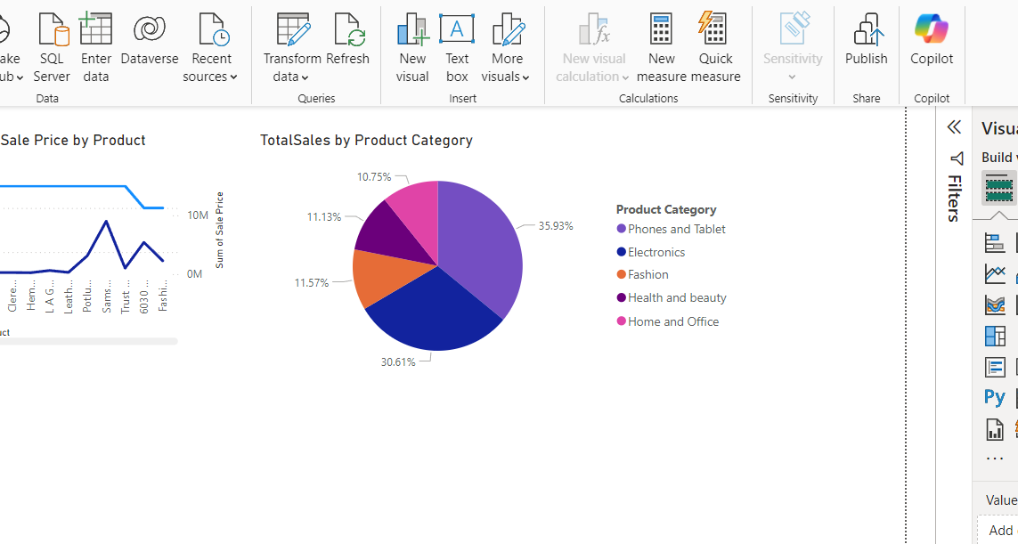

**Loyalty Program Ideas:**

* **Tiered Rewards for Top Categories**: Provide special incentives for customers who frequently purchase from high-performing categories. For instance, since **Phones and Tablets** account for 40% of total sales, offer extra points, exclusive discounts, or early access to sales for customers who buy from this category.
* **Seasonal Loyalty Offers**: Introduce targeted loyalty rewards during peak seasons for specific categories. For example, during the holiday season, offer extra points or discounts on popular categories to boost sales during this period.
* **Referral Rewards for Top Categories**: Encourage customers to refer friends and family by offering loyalty points or discounts on high-demand categories as a reward for successful referrals.

1. **Using the DAX functions Calculate and a row iteration DAX function calculate the total sales for the Product Category “Fashion” and delivery type “Shipped from Abroad”. What are the other types of DAX functions you have used in the project?**

**Reference:**

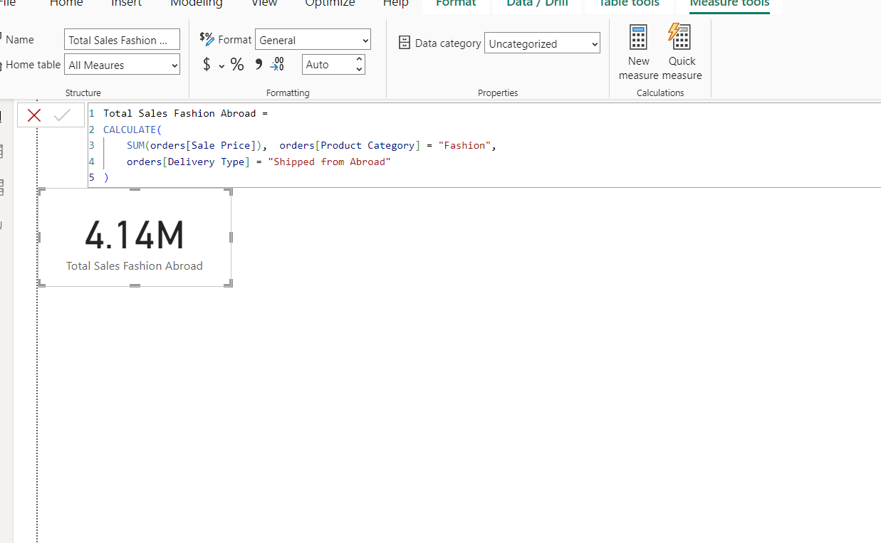

**Other DAX Functions:**

* **SUMX**: Iterates over a table and sums the expression for each row.



* **DISTINCTCOUNT**: Counts the number of unique, non-blank values in a specified column.





* **AVERAGEX**: Calculates the average over a table or expression.
* **FILTER**: Returns a table that represents a subset of another table based on a condition.
* **DATEDIFF**: Calculates the difference between two dates in a specified unit (e.g., days, months, or years).



* **CALCULATE**: Modifies the context of a calculation and evaluates an expression based on filters or conditions.
* **COUNTROWS**: Returns the number of rows in a table or table expression.



* **AVERAGE**: Calculates the average of a column.
* **ALLEXCEPT:** Removes filters from all columns in a table, except for the specified columns.

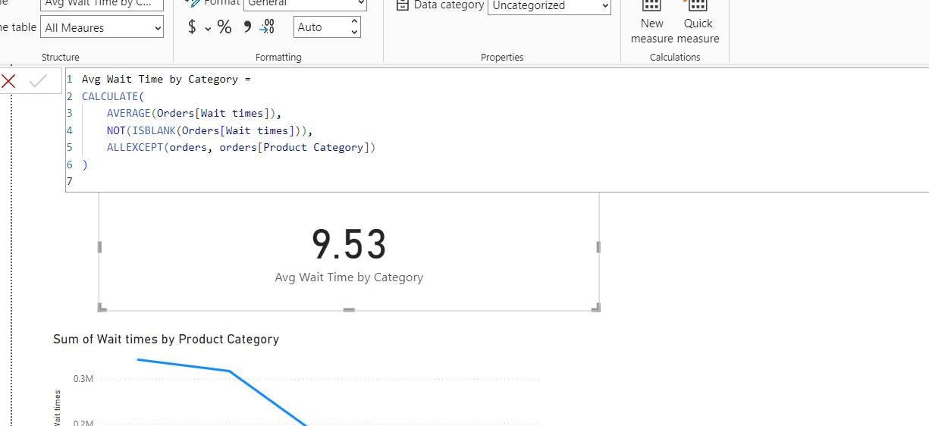

* **SAMEPERIODLASTYEAR**: Compares the current period with the same period from the previous year.

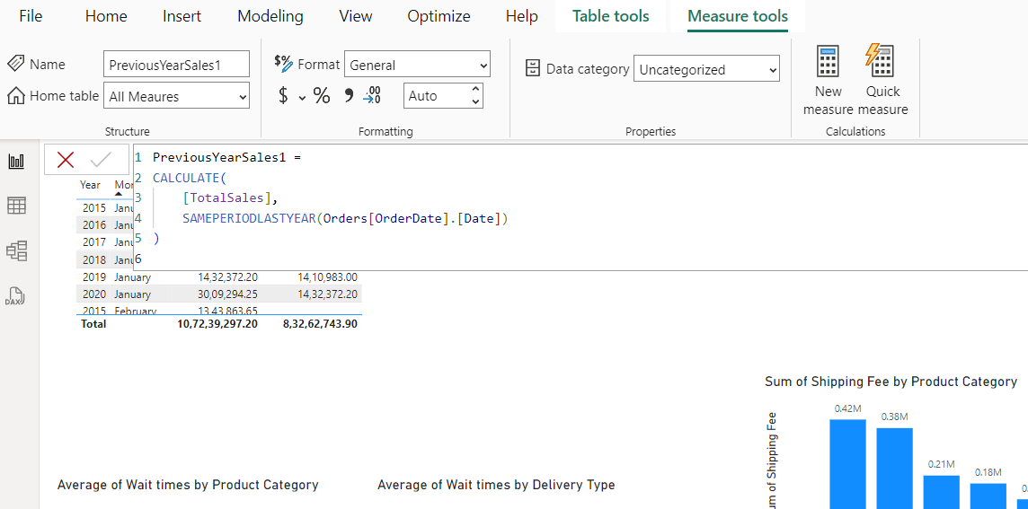

1. **Wait Times Correlated with Demographics and Care: Explore how average wait times vary across different product categories to optimize scheduling and staffing.**

**Reference:**



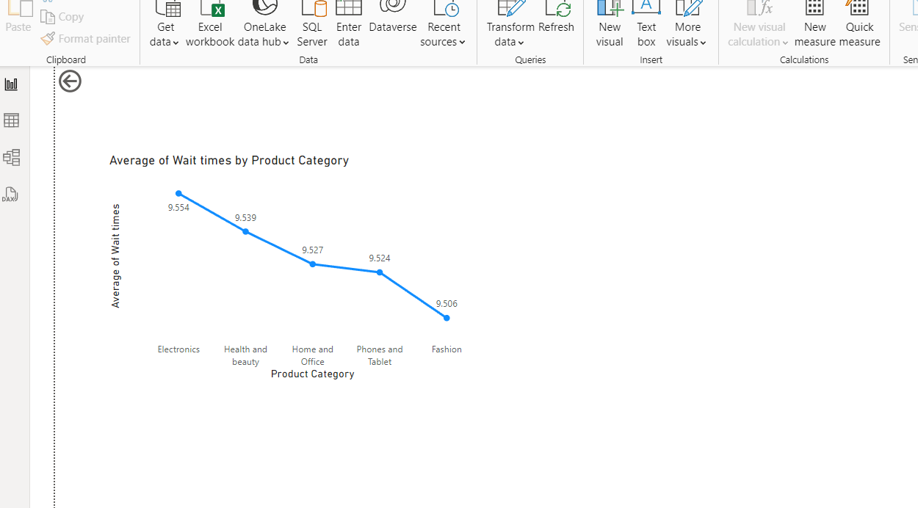

**Insights:**

* **Electronics** has the longest average wait time (9.554 days), indicating potential inefficiencies or delays in processing orders within this category.
* **Health and Beauty**, although slightly better than **Home and Office**, still experiences higher-than-average wait times, suggesting fulfillment issues in this category as well.
* **Fashion**, **Phones and Tablets**, and **Home and Office** have relatively closer wait times, with **Fashion** showing the lowest average, pointing to a more efficient processing system for this category.

**Strategies to Optimize Scheduling and Staffing:**

* Allocate more staff or optimize fulfillment processes to reduce delays, especially in the **Electronics** category.
* Ensure that current staff levels are maintained but be prepared to scale up during peak demand periods.
* Leverage data to forecast high-demand periods (e.g., holidays) and adjust staffing levels accordingly to ensure timely order fulfillment across all categories.

1. **Explore if there is any relationship between the Delivery type and waiting time between ordering and receiving an item.**

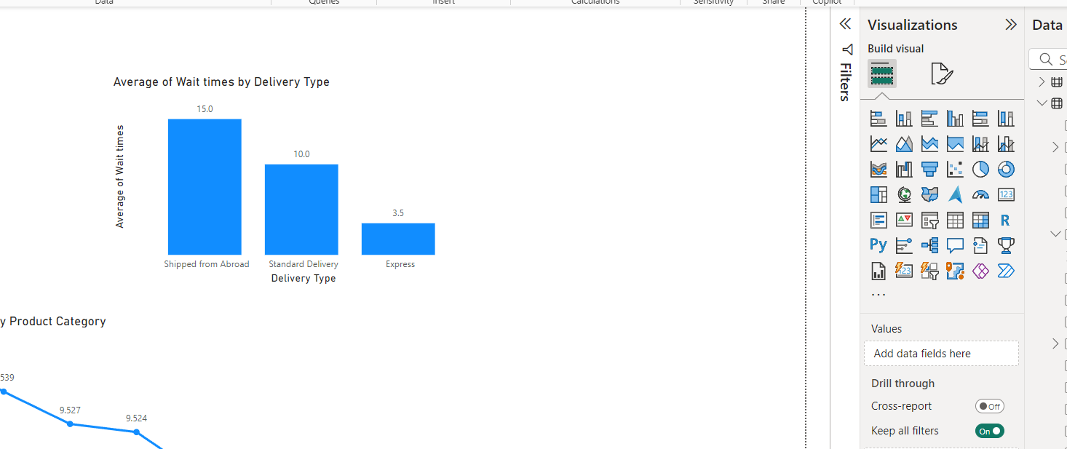

**Insights:**

* Shipping from Abroad has the longest average wait time (15.0 days), suggesting that international shipping or logistics may be causing significant delays, possibly due to extended transit times or limited shipping options.
* Standard Delivery has a moderate wait time of 10.0 days, indicating that domestic deliveries are relatively timely but could still be improved.
* Express Delivery has the shortest wait time (3.5 days), which caters to customers who prioritize speed. This fast service may also suggest that customers are willing to pay a premium for quicker delivery.

Recommendations:

* Partner with faster international carriers to shorten the wait times for Shipping from Abroad.
* Streamline customs clearance processes to reduce delays in international shipments.
* Ensure Express Delivery is prioritized during peak periods to maintain its fast 3.5-day delivery window.
* Implement improved tracking systems to keep customers updated on their orders and set clear expectations.
* Adjust staffing levels based on demand for different delivery methods, especially during peak seasons, to prevent delays.

1. **Is there any relationship between shipping charges and product type?**

**Reference:**

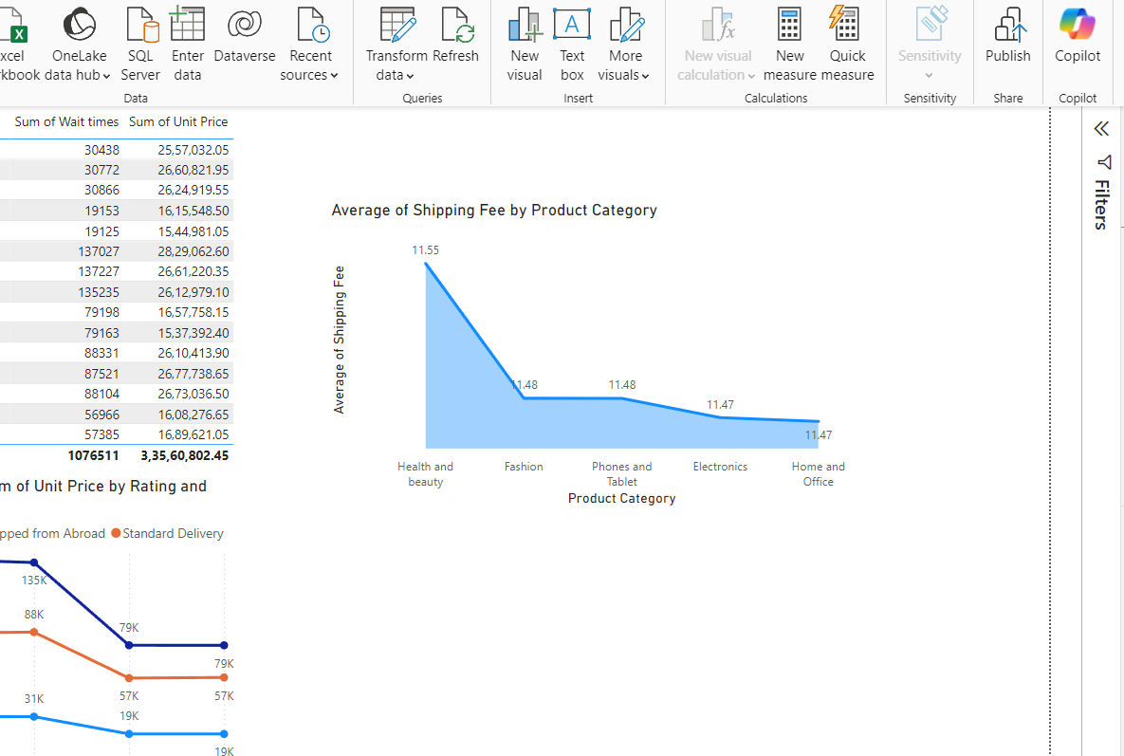

**Insights:**

* The shipping charges across all product types are nearly the same, ranging from 11.47 to 11.55. This indicates that there is little variation in shipping fees between these categories.
* This could suggest that the company applies a standardized shipping fee for all products, which is common in e-commerce businesses that use flat-rate shipping for simplicity and convenience.
* The small difference in shipping charges implies that the fees are likely determined by factors such as size, weight, or delivery location, rather than the specific product category.

1. **Come up with strategies to decrease the low rating orders after analyzing different factors like waiting time, shipping type, unit price, etc.**

**Reference:**

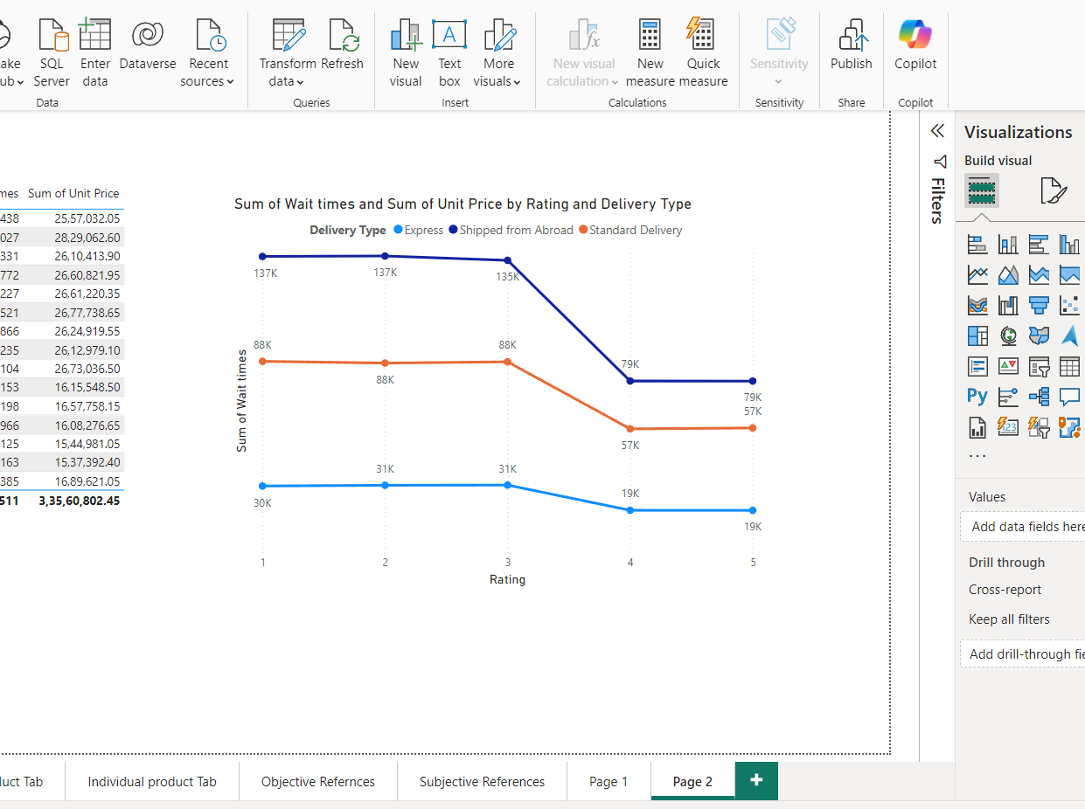

**Insights:**

* Longer wait times tend to correlate with lower ratings, especially for **Express** and **Shipped from Abroad** deliveries.
* **Express Delivery** maintains relatively high ratings despite longer wait times, indicating that customers prioritize speed over waiting.
* **Standard Delivery**, with average wait times, results in better ratings, suggesting that customers appreciate a balance between reasonable wait times and delivery efficiency.
* Low ratings despite short wait times suggest that factors beyond delivery speed, such as **product quality** or **customer service**, may also be influencing customer satisfaction.
* To improve overall ratings, focus on reducing wait times while also addressing other key factors like product quality and customer service.

1. **Using the time intelligence DAX function, create a table to compare each month’s sales with the previous year’s same month’s total sales. So there will be four columns in the output year, month, total sales, previous_years_sales.**

**Reference:**

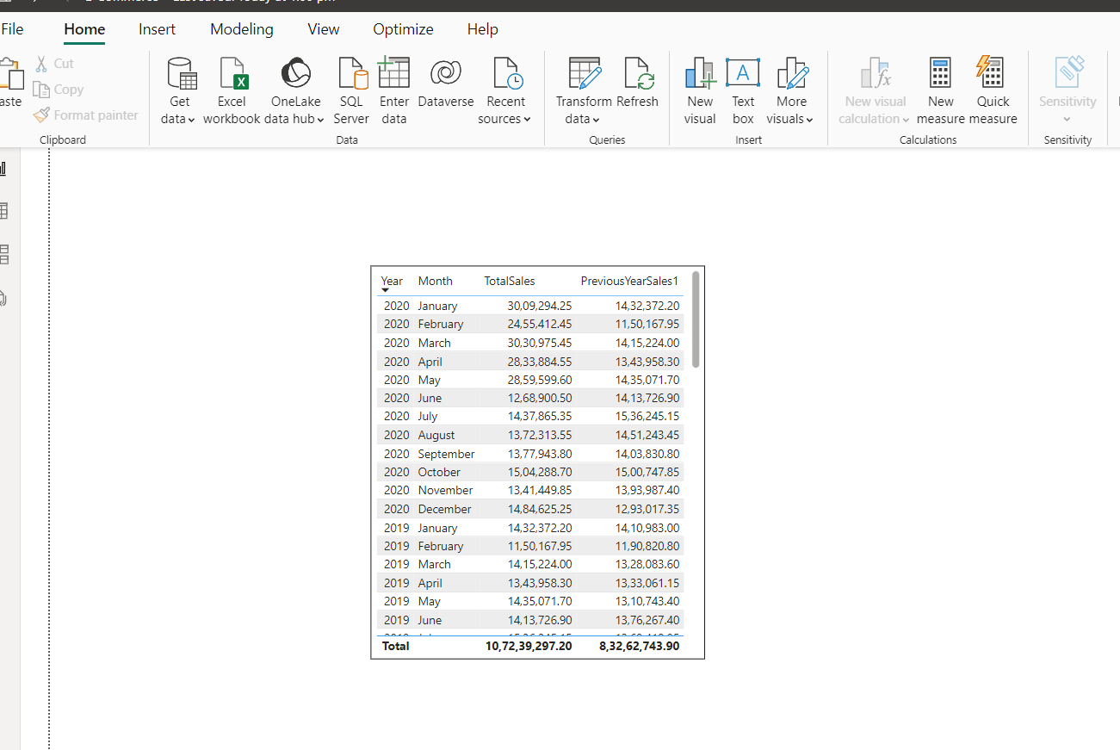

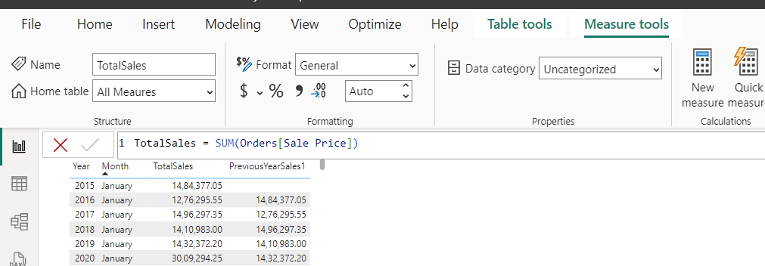



The DAX functions used are

* **SAMEPERIODLASTYEAR**: This function shifts the context to the same period in the previous year, making it easy to compare year-over-year performance.
* **SUM**: This function is used to sum the sales of that column.

1. **What do you understand by Power BI gateway? What are its use cases?**

* **Power BI Gateway** acts as a bridge between on-premises data sources and Power BI in the cloud. It facilitates scheduled data refreshes, enables connections to local databases, and ensures Power BI reports stay up-to-date.

**Use Cases of Power BI Gateway:**

* **On-Premises Data Integration**: The gateway enables seamless data transfer for businesses with on-premises databases.
* **Real-Time Data**: It supports real-time analytics, providing up-to-date insights.
* **Security**: The gateway ensures secure data transfer between on-premises systems and cloud services.
* **Hybrid Data Scenarios**: It allows organizations to manage and analyze data from both cloud and on-premises environments, supporting hybrid data setups.
* **Integration with Other Services**: Power BI Gateway integrates with other Microsoft services, such as Azure Analysis Services and SQL Server Analysis Services, to streamline the integration of analytics solutions.

1. **How would you approach this problem, if the objective and subjective questions weren't given?**

If objective and subjective questions were not provided in the given problem statement, here’s how I would approach the task:

* **Step 1 (Data Exploration):**  
  I would begin by exploring the dataset, reviewing the summary statistics to identify key trends. I would check for any missing values and address them accordingly, ensuring that data is cleaned by standardizing categories and resolving any inconsistencies.
* **Step 2 (Business Objective):**  
  Next, I would focus on identifying the core business objectives, such as increasing sales, optimizing delivery times, improving customer satisfaction, or enhancing product offerings. I would then pinpoint areas where the business can enhance performance and achieve these objectives.
* **Step 3 (Key Metrics):**  
  I would focus on key metrics that align with the business goals, such as total sales, customer satisfaction (ratings), product performance, and delivery efficiency. These metrics will help track overall business performance and highlight areas for improvement.
* **Step 4 (Dashboard):**  
  Lastly, I would create interactive visualizations in the form of dashboards. These dashboards would provide insights into sales by product, region, and time, enabling stakeholders to drill down into the data and make informed decisions.